Reporting Dashboards
Do you need interactive, real-time reporting surrounding data contained in an OnBase system?
If so, you will benefit from Reporting Dashboards. OnBase Users who need detailed and current views of their business data can immediately view that information through an interactive, easy to use graphical interface.
Available Dashboard Items include charts, pie charts, bar graphs, gauges, pivot tables, and maps. Of course, multiple Dashboard Items can be displayed in a single Dashboard!
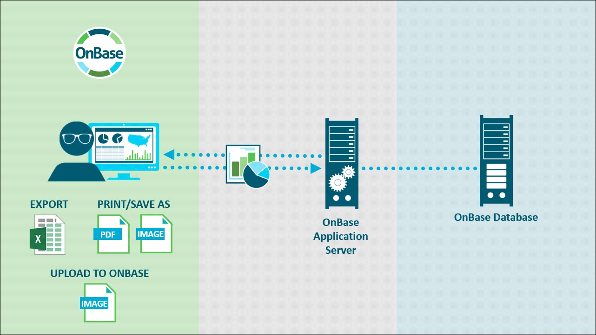
Hint: You can click on any image in this pane to enlarge it and view it in a new window.
How Reporting Dashboards Work
Data Providers are created, which return data (from a data source) to be displayed in a Dashboard.
Data for a Dashboard is displayed in a point and click graphical interface, that can contain real-time and interactive Dashboard components.
Dashboards are configured using the Dashboard Designer. Reporting Dashboards functionality is available in the Unity Client and Web Client.
Dashboards can also be opened from Web browsers (including mobile browsers), using the optional Reporting Viewer. This is great for users who may not have access to the Unity or Web Client!
Benefits of Reporting Dashboards
- Presents important data in real‐time
- Uncovers trends and likely bottlenecks
- Simplifies the display of data using graphical views
- Provides users with the ability to create their own reports
Key Features of Reporting Dashboards
- Point‐and‐click Dashboard Designer
- Export Dashboard information to Excel
- Dashboards can be shared with other OnBase users
- Open related OnBase items from Dashboard objects
- Data Provider wizards simplify the process of creating new data sources
- Interact with Dashboard Items to obtain more specific data
- Archive Dashboard images into OnBase for historical purposes
- Granular security
What's Covered in this Lab
- View preconfigured Dashboards from the end user's perspective
- Configure a Document Query Data Provider
- Create a new Dashboard
- Use the Dashboard Designer interface to add Dashboard Items
And more…
Additional Resources for this Course
For additional information, please visit the Documentation Portal and search on the following topics. A shortcut to the Documentation Portal (Doc Portal) is on the VM desktop.
- Reporting Dashboards
- System Administration
- Unity Client
Reporting Dashboards requires the Reporting Dashboards database license. If you have specific licensing questions, please contact your organization's Account Manager.
Accessing & Viewing Dashboards
- Launch the Unity Client from the desktop. Login with the following credentials
UN: MANAGER
PW: password
You may need to scroll to see the Login buttom.
Use Your Typing Assistant: When a word or phrase appears in Type Text font like above, clicking on it in the lab instructions will automatically input the text into the focused item in the VM.
- For best results, Maximize the Unity Client
- From the Home ribbon, click Reporting
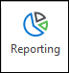
The Reporting Dashboard interface is displayed.
The Gallery pane is displayed on the left-side of the Dashboard interface. This pane allows you to access Dashboards you have created, as well as public Dashboards and Dashboards that are shared with you.
To view a Dashboard, simply click on the Dashboard item in the Gallery pane.
- Select the DASH - Workflow Info Dashboard
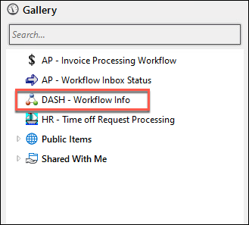
In a few moments, the Dashboard is displayed.
The Item Viewer pane (the main area to the right of the Gallery) displays components of the selected Dashboard.
The Item Viewer is a tabbed interface, meaning that you can open multiple Dashboards at the same time.
Notice the tab titled DASH - Workflow Info tab at the top of the Item Viewer.
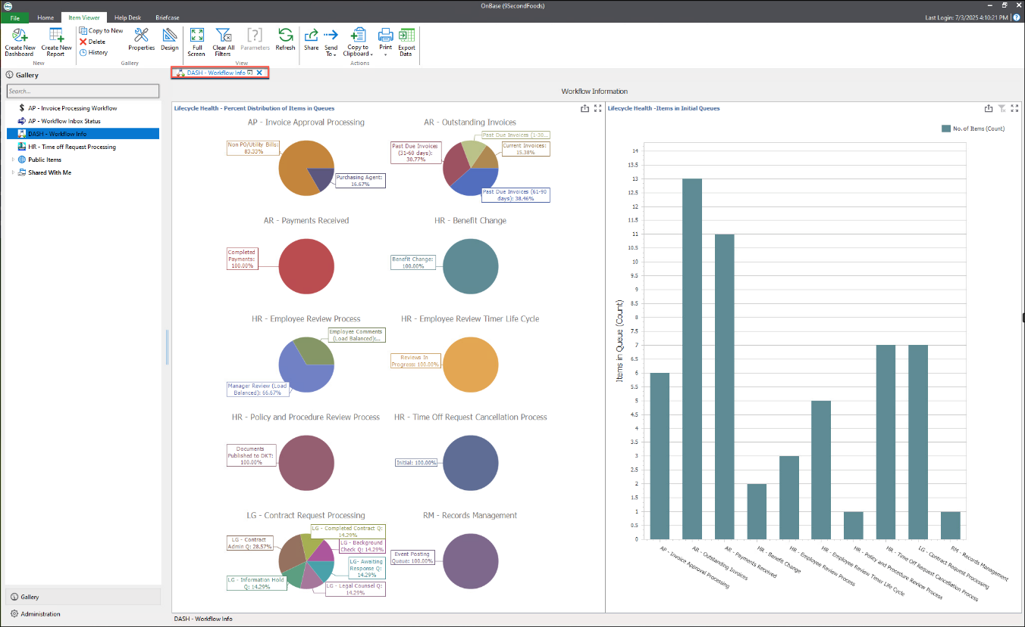
- Take a few moments to review the DASH - Workflow Info Dashboard
- When ready, navigate back to the Gallery pane. Click the Arrow to the left of Public Items to view the contents within. Select the AP - Invoices by State Dashboard
In a few moments, the Dashboard is displayed.
- Take a few moments to review the AP - Invoices by State Dashboard
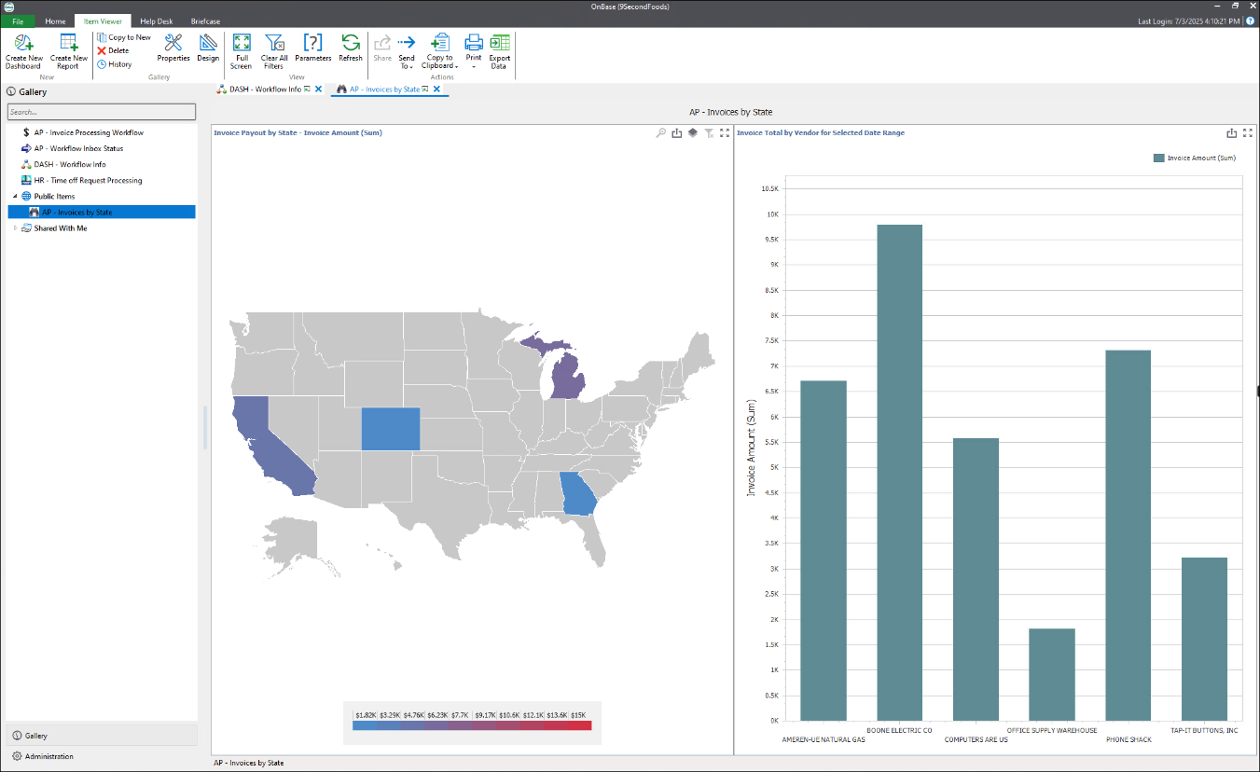
The AP - Invoices by State Dashboard is displayed in a second tab in the Item Viewer.
You can click on a tab to display an open Dashboard as needed. You can also close a Dashboard by clicking the X (right-side of the tab).
If you'd like to track your progress for this lab, you can check every item as you complete it or simply check the last item of a page as complete to mark all tasks above it as finished.

User Interface
Complete the following activities to become more familiar with the Reporting Dashboards interface and functionality.
- Navigate back to the Gallery
- Click the Arrow to the left of Shared With Me then click the Arrow to the left of Sample Dashboards
- Select the Document Counts by Document Type Dashboard
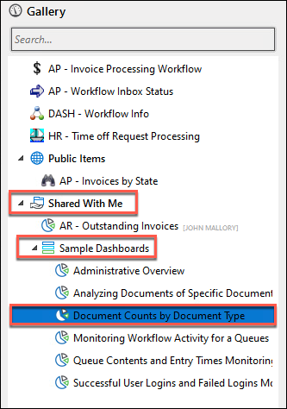
The Parameters dialog is displayed. This is an optional Dashboard feature. This dialog gives the user the ability to input specific parameters.
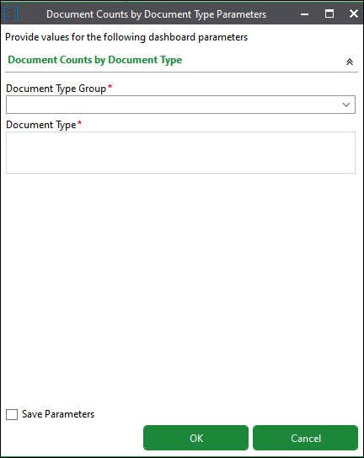
- Use the Document Type Group drop-down and select Accounts Receivable
- Select all of the Accounts Receivable Document Types by pressing the CTRL key on your keyboard, while clicking on all of the available Document Types. Release the CTRL key once all of the Document Types are selected
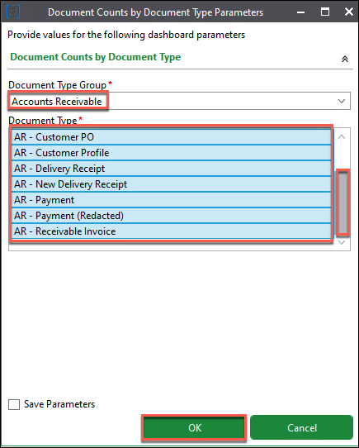
- Click OK
The Document Counts by Document Type Dashboard is displayed.
Note: Your results may differ slightly from those illustrated.
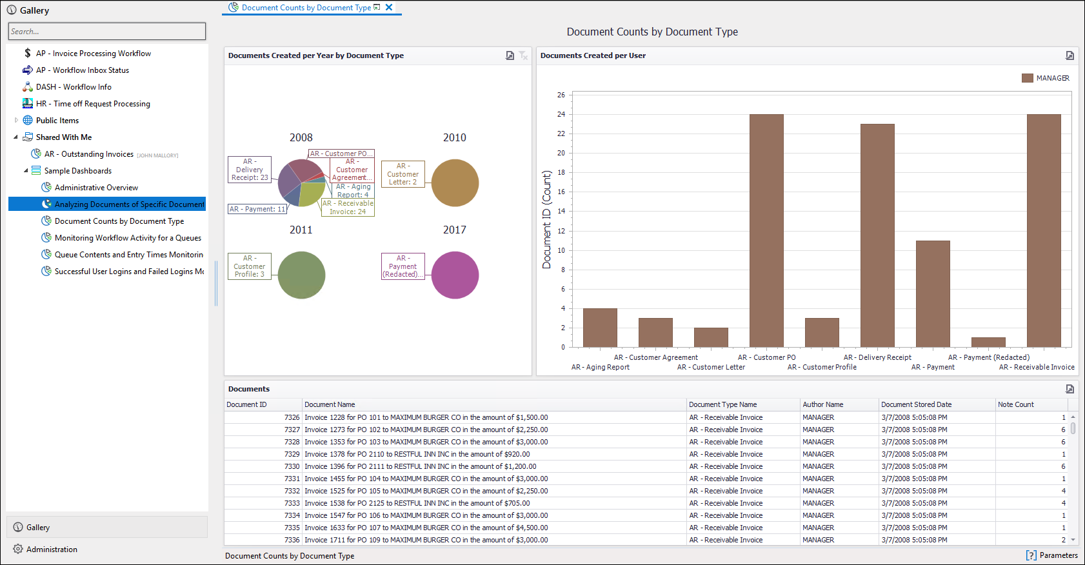
- Take a few moments to review the Dashboard
- Double-click the Title Bar of the Dashboard Item named Documents (lower left-center area) to enlarge the view
- When ready, click in the dark area surrounding the (enlarged) Dashboard Item to return to the Item Viewer
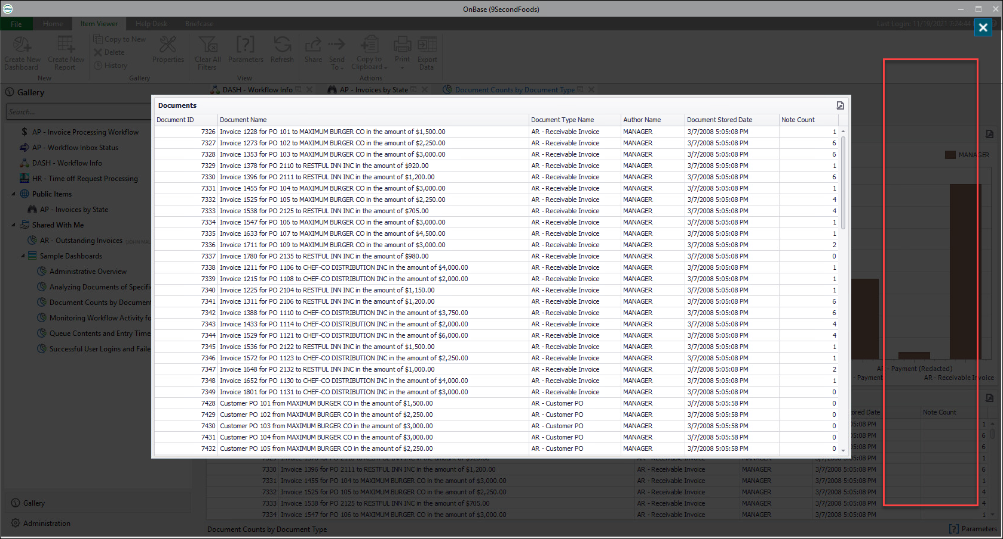
- From the Item Viewer ribbon, click Full Screen (to switch to Full Screen mode)
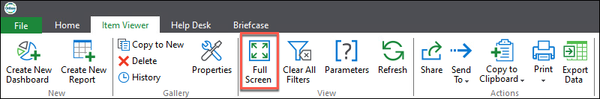
- While in Full Screen mode, right-click anywhere in the Dashboard and select Change Theme
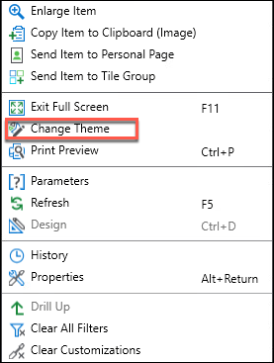
The Full Screen Theme dialog is displayed.
- Click on a few different themes
Once you have found a visually pleasing theme, highlight the theme name and then click the Apply button.
Dashboard Themes are only visible when you are viewing a Dashboard in Full-Screen mode. The Change Theme option is also only available in Full-Screen mode.
- Press the F11 Key on the keyboard to toggle the Full Screen off
If you have any issues while using the F11 Key, right-click anywhere in the Dashboard and select Exit Full Screen.

Add to Personal Page
A Personal Page gives you the ability to access shortcuts and frequently used features from one single location in the Unity Client.
- From the Item Viewer ribbon, click Send To and then select Personal Page from the resulting menu
This will create a tile (shortcut) on your Personal Page from which you can access the Document Counts by Document Types Dashboard directly.
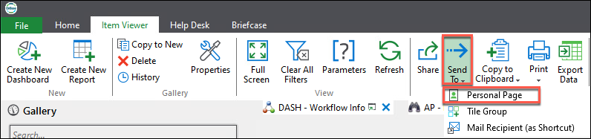
- From the Home ribbon, click Personal Page
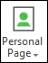
The Personal page interface is displayed.
- Confirm that you have a tile on your Personal Page that looks similar to the one illustrated below
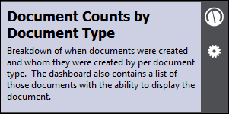
At this point, please do not click on the new tile, as you would have to input new parameters.
You can also right-click on an individual Dashboard Item to create a tile for it on your personal page.
- From the Home ribbon, click Reporting to return to the Dashboard interface
Drill-Down & Filtering
- Click on the AR - Delivery Receipt section of the 2008 pie chart in the Documents Created per Year By Document Type Dashboard Item
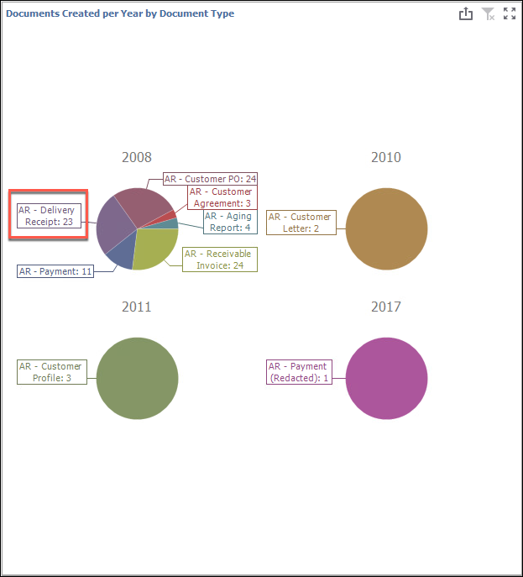
Other Dashboard items are changed to reflect this selection. In essence you have drilled-down into (or filtered) the original Dashboard information.
- Right-Click anywhere on the Dashboard and select Clear All Filters to remove the filter that you've just applied
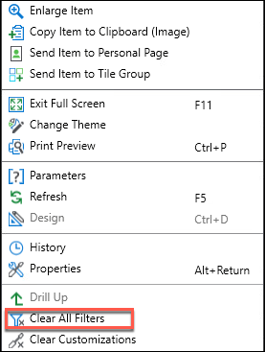
Clear All Filters is also available in the Item Viewer ribbon.
Please remain in the Document Counts by Document Type Dashboard for the next exercise.
- From the Item Viewer ribbon, click Copy to Clipboard and then select Copy Hyperlink from the resulting menu
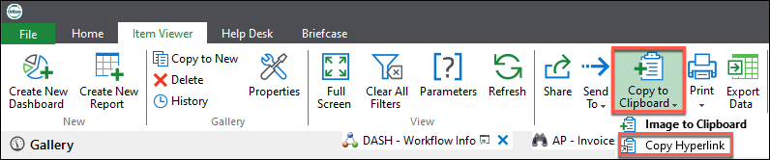
The Create Integration Hyperlink privilege is required to use the Copy Hyperlink option.
The Create Dashboard Hyperlink dialog is displayed.
- From the * Document Type Group* drop-down, select Accounts Receivable.
- Under Document Type, select all of the Accounts Receivable Document Types
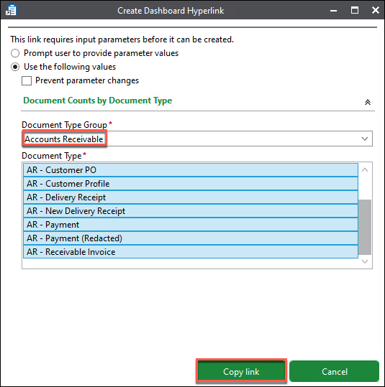
- Click Copy Link
Note: If a Dashboard contains no parameters, the link is copied directly to the clipboard and no Create Dashboard Hyperlink dialog (like we saw in this example) is displayed. Either way, the link can be pasted into another application (like email) so that the recipient can access the Dashboard in a Web Browser.
- Minimize the Unity Client
- Launch a Web Browser from the Windows Taskbar
- Click inside of the Address field (to highlight the current web address)
- Right-click on the highlighted address and select Paste (to paste the Dashboard address into the Address field)
- Press the Enter key on your keyboard
In a few moments an OnBase Login screen is displayed.
- Login with the following credentials:
UN: MANAGER
PW: password
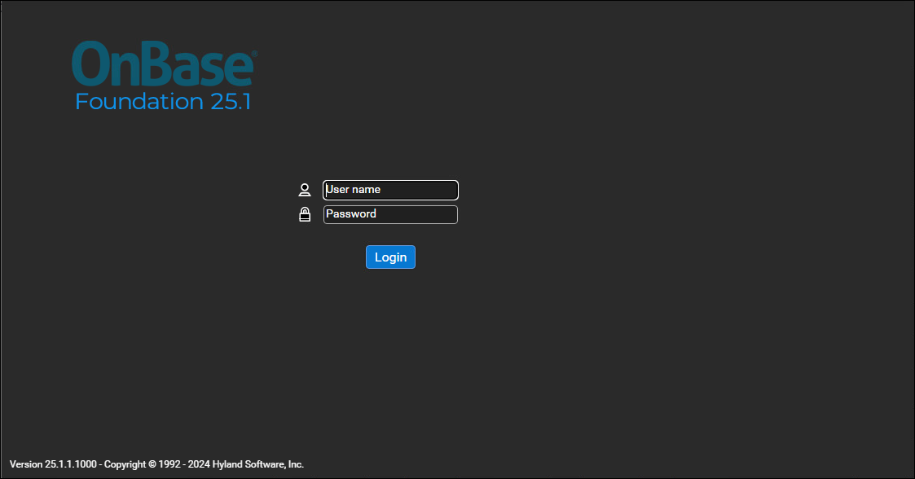
- Click Login
- The web-based Dashboard is displayed (your results may look slightly different)
We are using an OnBase module called the Reporting Viewer in this example.
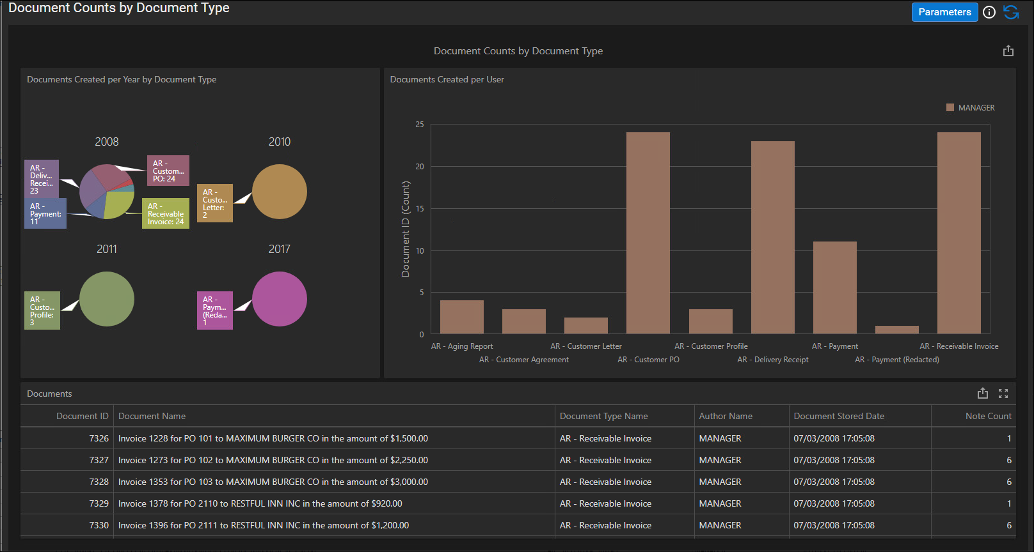
- Review the Dashboard information. When ready, Close your Web Browser
- Maximize the Unity Client
Since OnBase 17, the ability to view a Dashboard in a Web Browser is also available to users of the OnBase Web Client. Simply log into the OnBase Web Client, navigate to the main menu and select Reporting Dashboards | Gallery.

Data Provider Overview
A Data Provider is a tool that is used to get data from within OnBase to display in a Dashboard.
Data providers are created using wizards that walk you through configuration options for each Data Provider Type.
Once you create a Data Provider, you add it to a Dashboard. This enables the display of information visually through the use of different Dashboard Items, such as bar charts, grids, pie charts, maps, and other graphical representations.
Data Providers are not limited to one per Dashboard; a Data Provider can be used on a number of different Dashboards and a Dashboard can display data from a number of different Data Providers.
A Dashboard must have least one Data Provider assigned to it in order to function.
Available Data Provider Types with All Installations
Data Provider Type | Used when you want to…
Custom SQL Query | …display data other than what can be configured using the standard data provider Wizards.
Document Imaging Query - Time in Queue | …retrieve time in queue data or total time from Scan to Commit (includes idle time in queue).
Document Imaging Query - Time to Process | …retrieve time to process data for batch processes.
Document Query | …retrieve information relative to Documents, Document Types, and Keywords that are stored in OnBase.
The following modules also have data provider types available for use with Reporting Dashboards:
- Plan Review
- Report Capture
- Workflow
- WorkView
- Document Knowledge Transfer & Compliance
The Data Provider types available in your environment will depend on licensing.
For details on configuring license-specific data provider types, search within the Documentation Portal for that module.

Document Query Data Provider
The Document Query Data Provider type is used when you want to retrieve information relative to Documents, Document Types, and Keywords that are stored in OnBase.
- Click Administration (bottom-part of the Gallery pane)
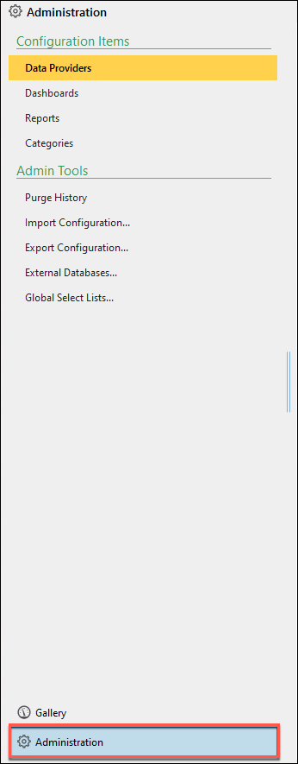
The Administration pane is displayed (replacing the Gallery pane).
With the proper permissions, the Administration area allows you to configure several aspects of Reporting Dashboards and perform administrative functions.
- Under Configuration Items, verify that Data Providers is selected
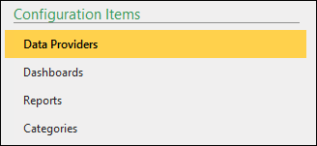
- From the Data Provider Administration ribbon, click Create New Data Provider
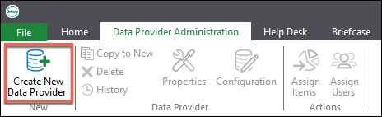
The Create Data Provider Wizard is displayed.
- On the How would you like to create the data provider? screen:
a. Select: New Data Provider
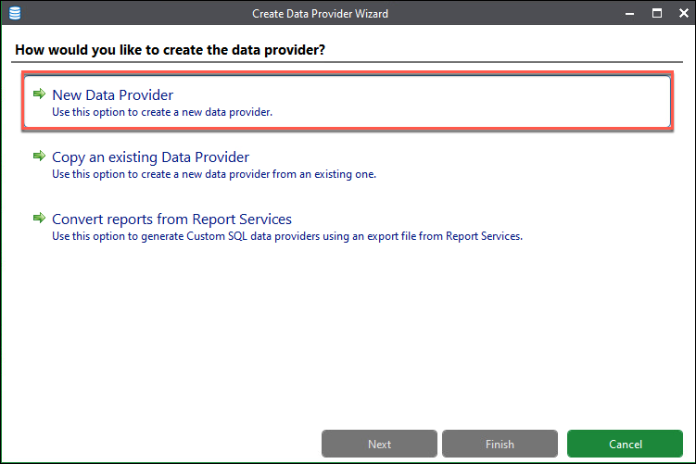
- On the What would you like to name this data provider? screen:
a. Name: DASH - Open Invoice Information
b. Description: This data provider gathers the document information on open invoices.
c. Log data provider execution - keep this at the default value (checked)
The log data provider execution selection includes the elapsed time of data retrieval and runtime parameter information for this data provider in the History log. Data requests for the data provider are always logged in the history even if this option is deselected.
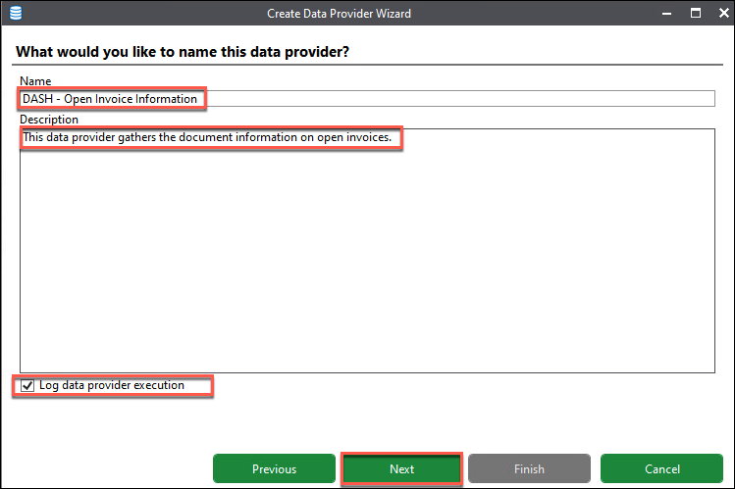
d. Click Next
- On the Select the type of data you would like to report on screen:
This is the location where you will see the list of the Data Provider Types available in your system.
a. Select Document Query
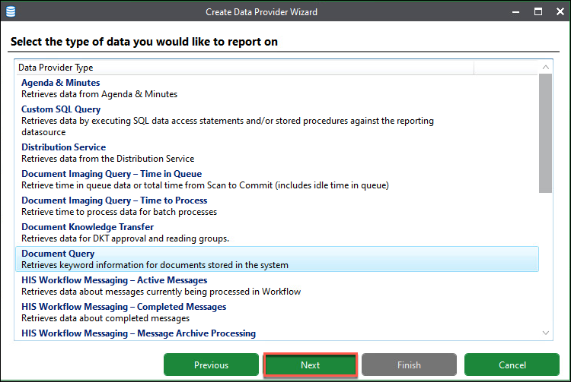
b. Click Next
The Select Document Types dialog is displayed.
c. Locate and then click on the DASH - Vendor invoice Document Type
The check box to the left of the DASH - Vendor invoice Document Type is selected.
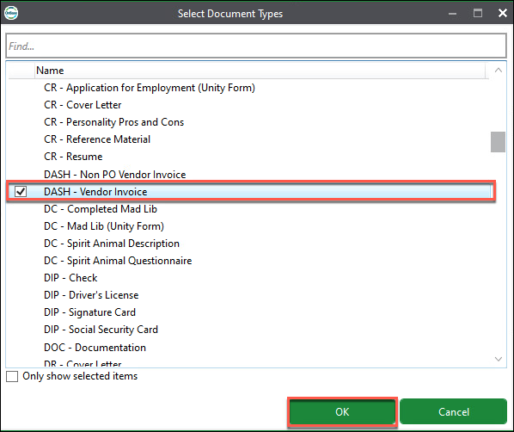
d. Click OK
- On the Select the document types to be retrieved screen:
a. Accept all defaults
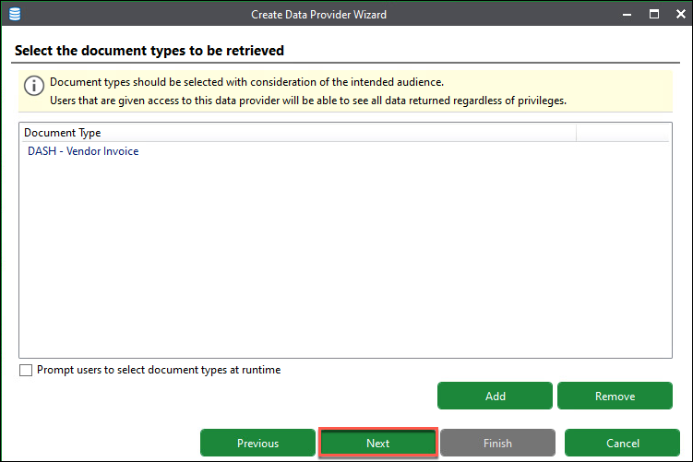
b. Click Next
- On the Select options on how the data provider retrieves data screen:
a. Accept the defaults (only the Respect Security Keywords check box is selected)
b. Click Next
- On the Add keywords to be returned by this data provider screen:
By default, certain system values display when you are first presented with this screen (as illustrated below).
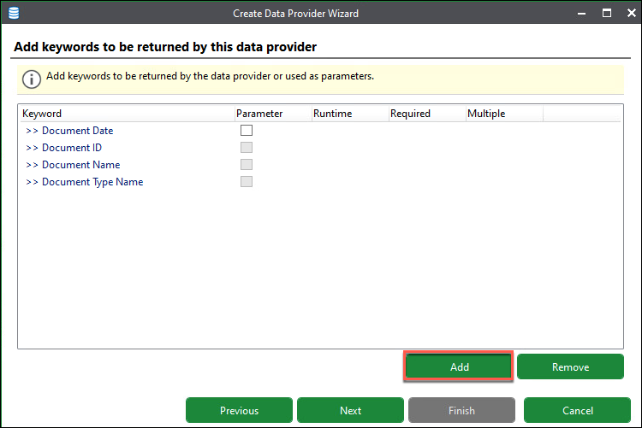
a. Click Add
The Select Keywords dialog is displayed, offering the ability to select Keyword values to display and/or use as parameter(s).
This dialog will display a list of all of the Keyword values for every Document Type you have selected for a Data Provider.
b. Locate then click on each Keyword listed below (one at a time). The check box to the left of Keyword will display, confirming selection:
Invoice #
Invoice Amount
Invoice Date
State
Status
Vendor Name
c. Click OK
You are returned to the Add keywords to be returned by this data provider screen.
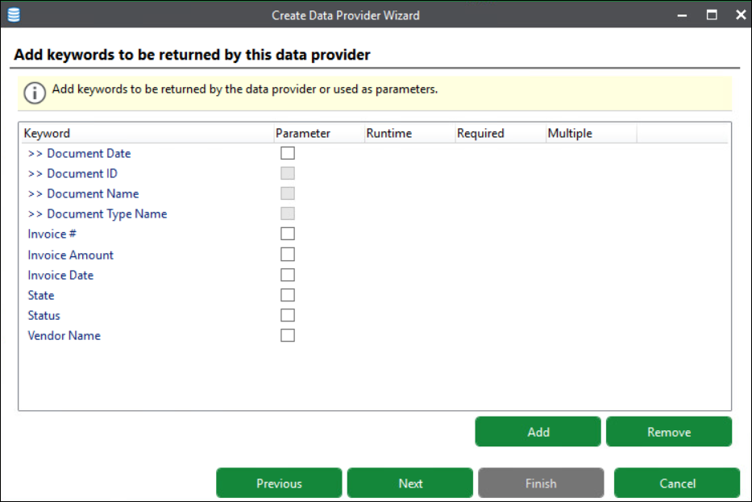
>>Document Date is the only system value that can be used as a parameter.
d. Select the Parameter check box to the right of the Status Keyword Type
If the Parameter check box is selected, you can configure additional options for the parameter:
Runtime: Help to limit the data returned by the data provider. The user can change the parameter value to something other than the default if desired.
Required: If Runtime is selected, you can also select the Required option to force the user to enter a value for the Keyword Type before returning data for the data provider.
Multiple: Select this option to allow the user to select multiple values for the parameter if the parameter is a drop-down select list.
e. Select the Runtime check box (to the right of the Parameter check box) for the Status Keyword Type
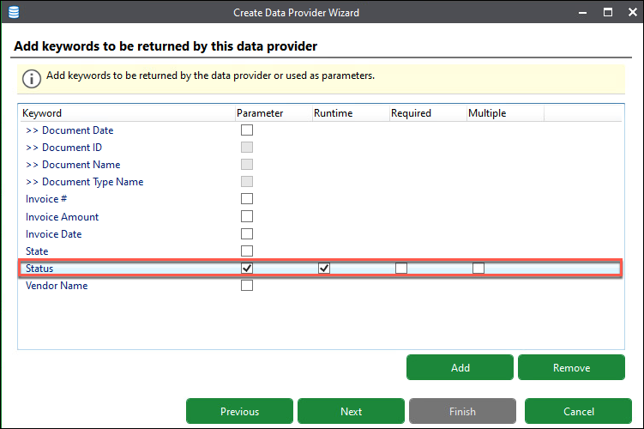
f. Click Next
- On the Provide default values for the input parameters screen:
a. Type OPEN in the Status field to be used as the default value
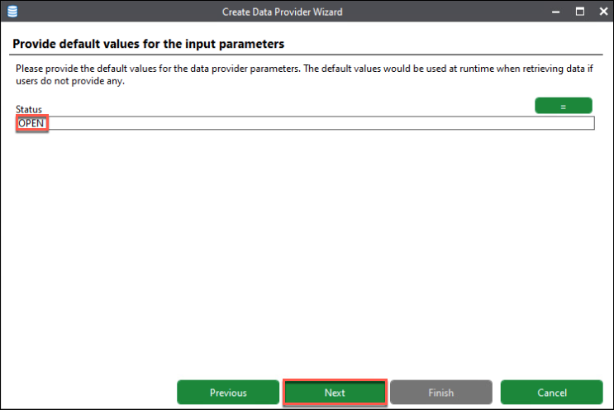
b. Click Next
- On the Choose the display columns for the data provider screen:
During this step, we will see a preview of the actual data that will be returned by this Data Provider to determine if the configuration is correct.
We can also deselect display columns (added during step 9) and/or rename and reorder display columns as needed.
a. Deselect the Document ID and the Document Name check boxes.
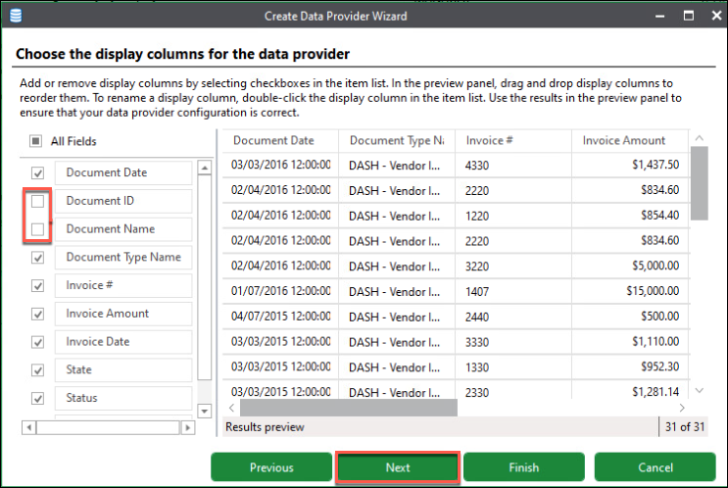
b. Click Next
- On the Who should have access to this data provider? screen:
Access to Data Providers is independent from access to Dashboards; therefore, for a user to be able to view data on a Dashboard, that user must have access to both the Data Provider and the Dashboard.
a. Click Add
The Select Users dialog is displayed.
b. Locate and then click on each User listed below (one at a time). The check box to the left of the User Type is selected.
Administrator
Bryan Stevens
The MANAGER user has permissions by default because the MANAGER user is the user creating the Data Provider.
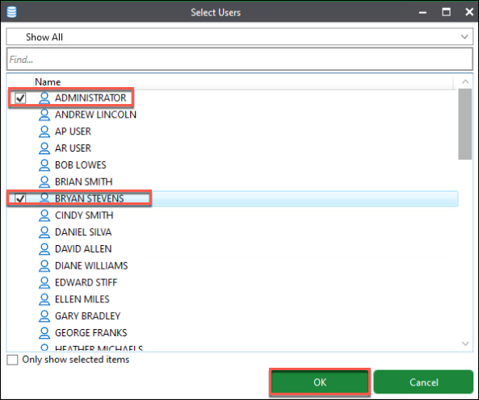
c. Click OK
The Grant User Access dialog is displayed.
The wizard presents a warning if a user you are attempting to assign access to a Data Provider or Dashboard does not have the rights to view the Document Type(s) in OnBase. Users do not need to be granted access to Document Types in order to view Dashboard data.
d. Click the Affected Users drop-down
In this example, we are granting access to data Bryan Stevens does not have (Document Type) access to.
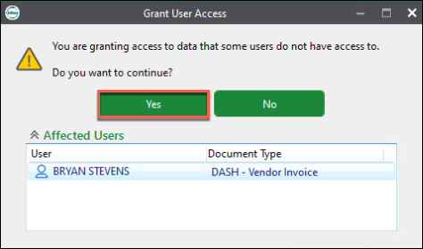
e. Click Yes
You are returned to the Who should have access to this data provider? screen.
By default, Bryan and the Administrator user were given Execute Only access to the Dashboard.
We will keep this access at Execute Only.
The MANAGER user has Full Control (and is the owner because the MANAGER user created the Dashboard).
Access cannot be changed for the owner.
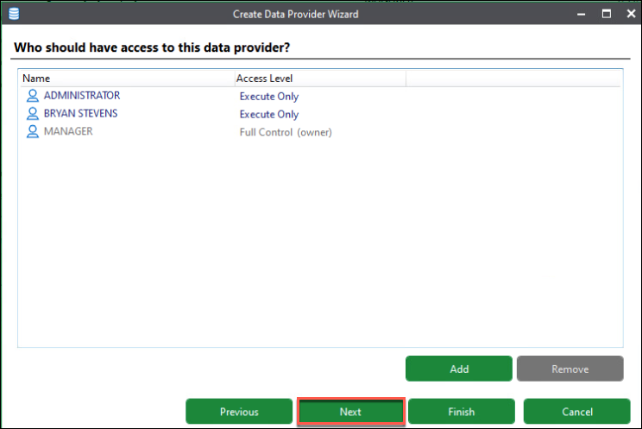
f. Click Next
- On the Summary screen:
a. Review the selections from the previous steps
b. Once ready, click Finish
You are returned to the Administration | Configuration Items | Data Providers screen
The new Data Provider is complete!

Create a New Dashboard
- In the Administration pane, select Dashboards
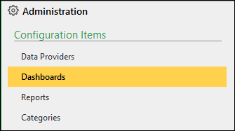
- From the Dashboard Administration ribbon, click Create New Dashboard
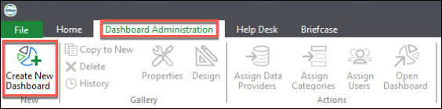
The Create Dashboard Wizard is displayed
- On the How would you like to create the dashboard? screen:
a. Select: New Dashboard
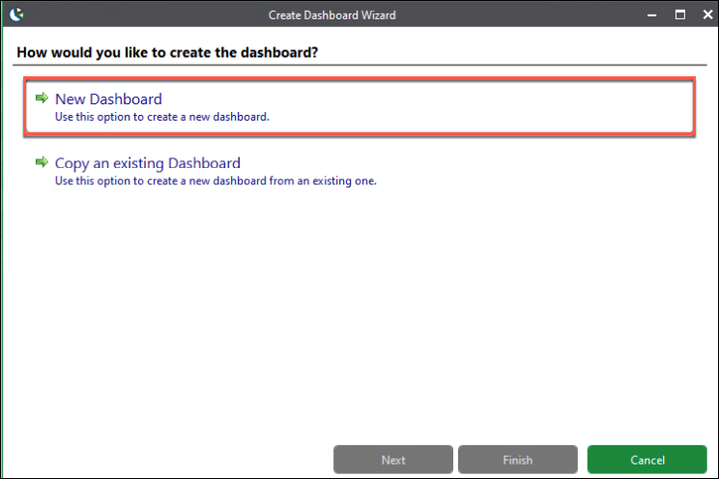
- On the What would you like to name this Dashboard? screen:
a. Name: DASH - Open Invoice Overview
b. Make this dashboard public: Keep this check box unchecked
Only members of User Groups with the Administrator Access privilege can make a Dashboard public.
c. Description: This Dashboard displays information on open invoices by state.
d. Icon: Please do not select an Icon
e. Dashboard refresh rate (seconds): Keep the default settings: (0) Seconds
Dashboard refresh rate is the number of seconds between automatic refreshes of the Dashboard.
Only members of User Groups with the Administrator Access privilege can set the refresh rate of a Dashboard.
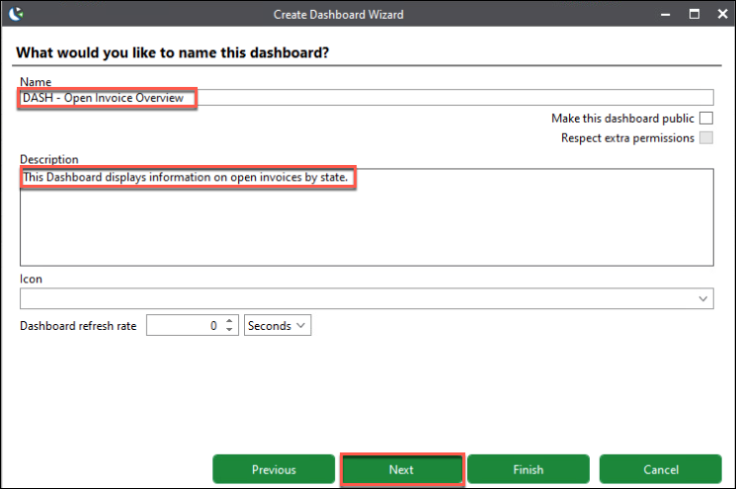
f. Click Next
- On the Assign data providers to this dashboard screen:
a. Click Add
The Select Data Providers dialog is displayed.
b. Locate and then click on the DASH - Open Invoice Information Data Provider
The check box to the left of the Data Provider is selected.
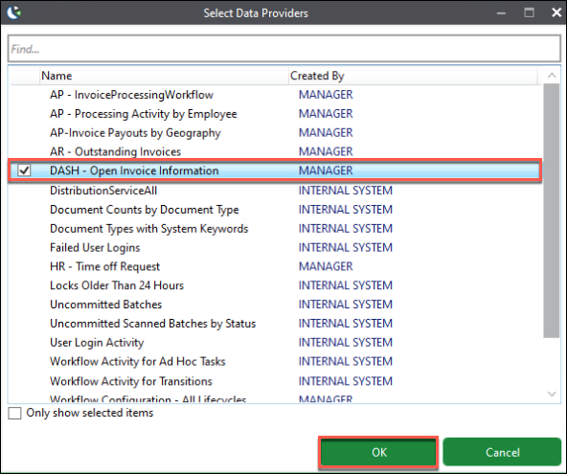
c. Click OK
You are returned to the Assign data providers to this dashboard screen.
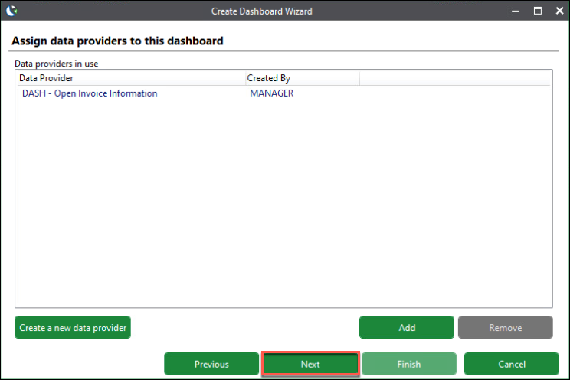
d. Click Next
- On the Who should have access to this dashboard? screen:
a. Click Add
The Select Users dialog is displayed.
b. Locate and then click on Bryan Stevens. The check box to the left of Bryan Stevens is selected.
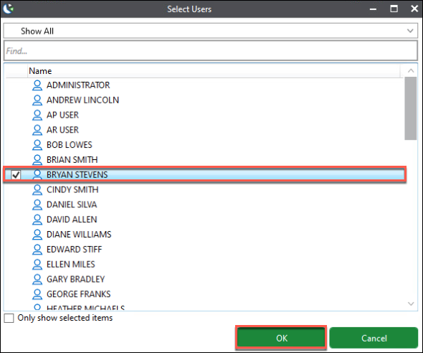
c. Click OK
You are returned to the Who should have access to this dashboard? screen.
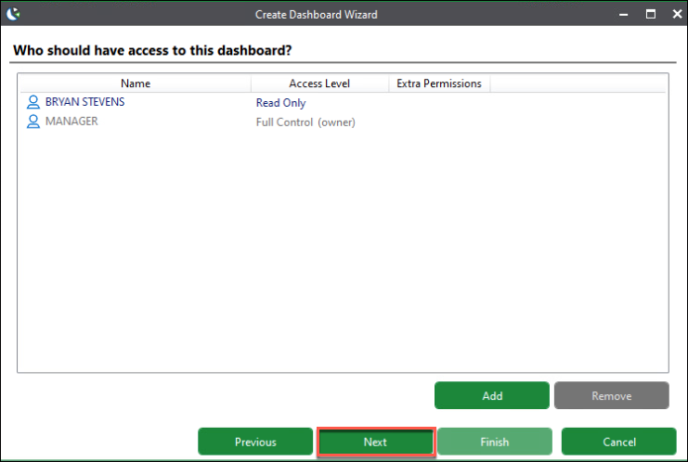
By default, Bryan is given Read Only access to the Dashboard. We will keep his access at Read Only.
The MANAGER user has Full Control (and is the owner because the MANAGER user created the Dashboard).
Again, access cannot be changed for the owner.
For Reference Only:
Please do not perform the following steps.
To change a user's Access Level, right-click the user's name and select an Access Level option.
Access Levels:
- Read Only: The user can view the Dashboard but cannot change or delete the Dashboard.
- Modify: The user can view and modify the Dashboard but cannot delete it.
- Full Control: The can view, modify, and delete the Dashboard.
In addition to granting various Access Levels, you can also grant users Extra Permissions when necessary.
To grant a user Extra Permissions, right-click the user's name and select an Extra Permission option.
Extra Permissions:
- Re-Share Dashboard: The user can share the Dashboard with others.
- Export Dashboard Data: The user can export the data that was used to create the Dashboard.
- Add/Remove Data Providers: The user can change the Data Providers used to retrieve data for the Dashboard (only available if the user has Modify access).
If a user has Full Control access, all extra permissions are included by default and cannot be removed.
d. Click Next
- On the Summary screen:
a. Review the selections from the previous steps
b. Locate the Launch dashboard designer check box. Notice that the check box is selected by default (please keep it selected)
c. Once ready, click Finish
In a few moments, the Dashboard Designer interface is displayed.
- Locate the Data Source drop-down (upper-left corner) and select the DASH - Open Invoice Information Data Source
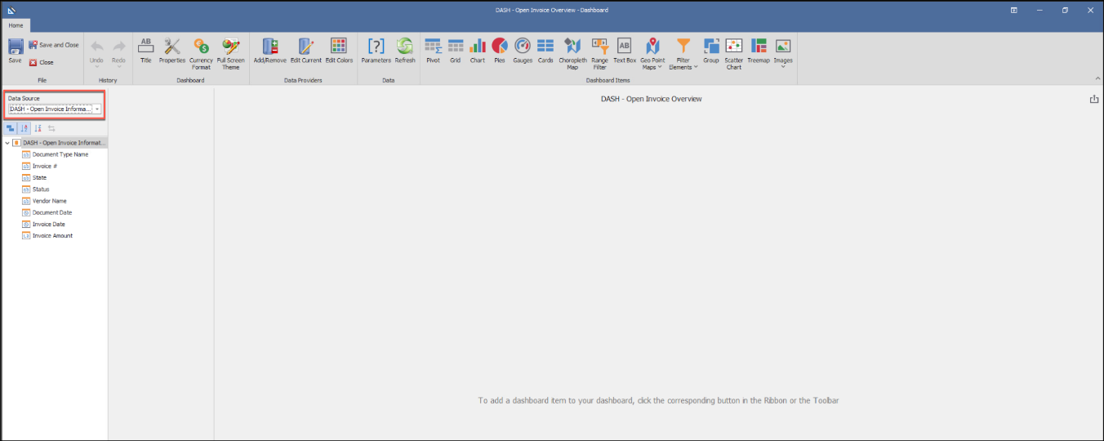

Dashboard Designer Overview
The Dashboard Designer is used to configure how the data in a Dashboard is presented to users.
Right now, we have created a Data Provider to retrieve data from OnBase around our DASH - Vendor Invoice Document Type. But, we have not designed the Dashboard to display information.
Let's do that now!
Dashboard Designer Elements:
A: The Dashboard Designer Home ribbon is used to open various properties and controls and to add design elements to the Dashboard.
B: The Data Provider pane is used to select the Data Provider to use for a design element and configure calculations for the data returned.
C: The Main Design area is used to place, size, and configure the Dashboard's design elements.
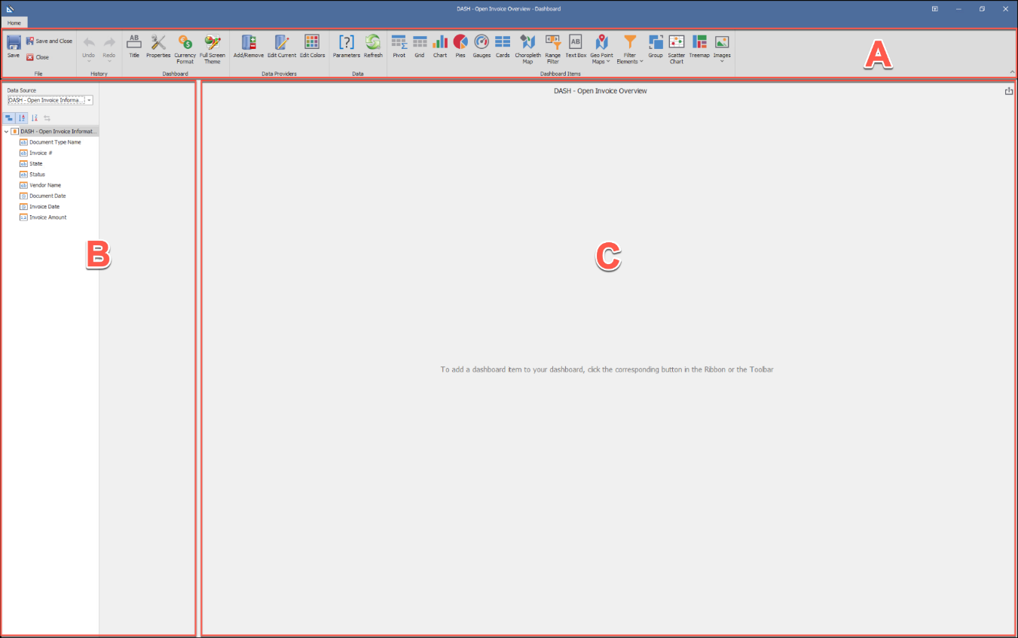

Chart Dashboard Item
A Chart inserts a visual diagram with an X-Y axis.
Value Data Item: Displays the data along the Y (vertical) axis (typically a numeric measure).
Arguments Data Item: Displays data along the X (horizontal) axis (typically a sub-group within a bigger group).
- From the Dashboard Designer Home ribbon, click Chart
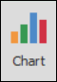
All Dashboard Items that appear in the Dashboard Designer can be repositioned and resized.
- From the Data Provider pane list (far-left), drag the following column names onto the appropriate Data Item in the Data Items (right side of the Data Provider pane) as illustrated below:
  - Invoice Amount to the Value Data Item blank.
  - Vendor Name to the Argument Data Item blank.
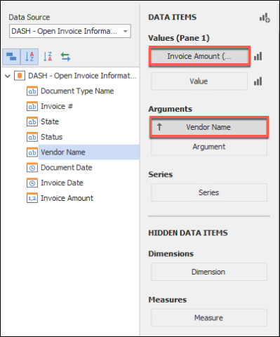
The Sum attribute has been added by default to the Invoice Amount value, which is what we want.
This attribute can be changed using the drop-down located to the right of the value being used (if needed).
This drop-down only appears while hovering over or clicking on a value.
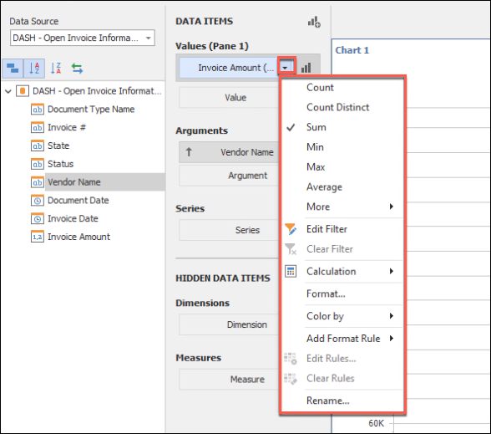
- Navigate to the Dashboard Designer Design ribbon and click Edit Names
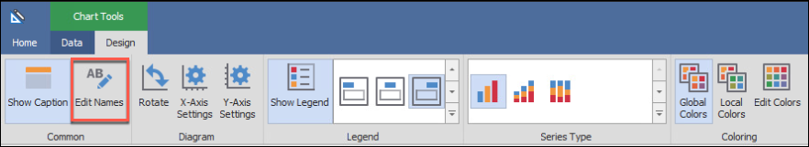
The Edit Names dialog is displayed.
- Type Open Invoice Total by Vendor in the Dashboard Item Name field
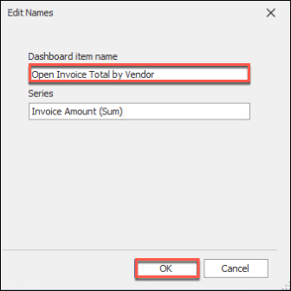
- Click OK
The Chart should look somewhat like the illustration below.
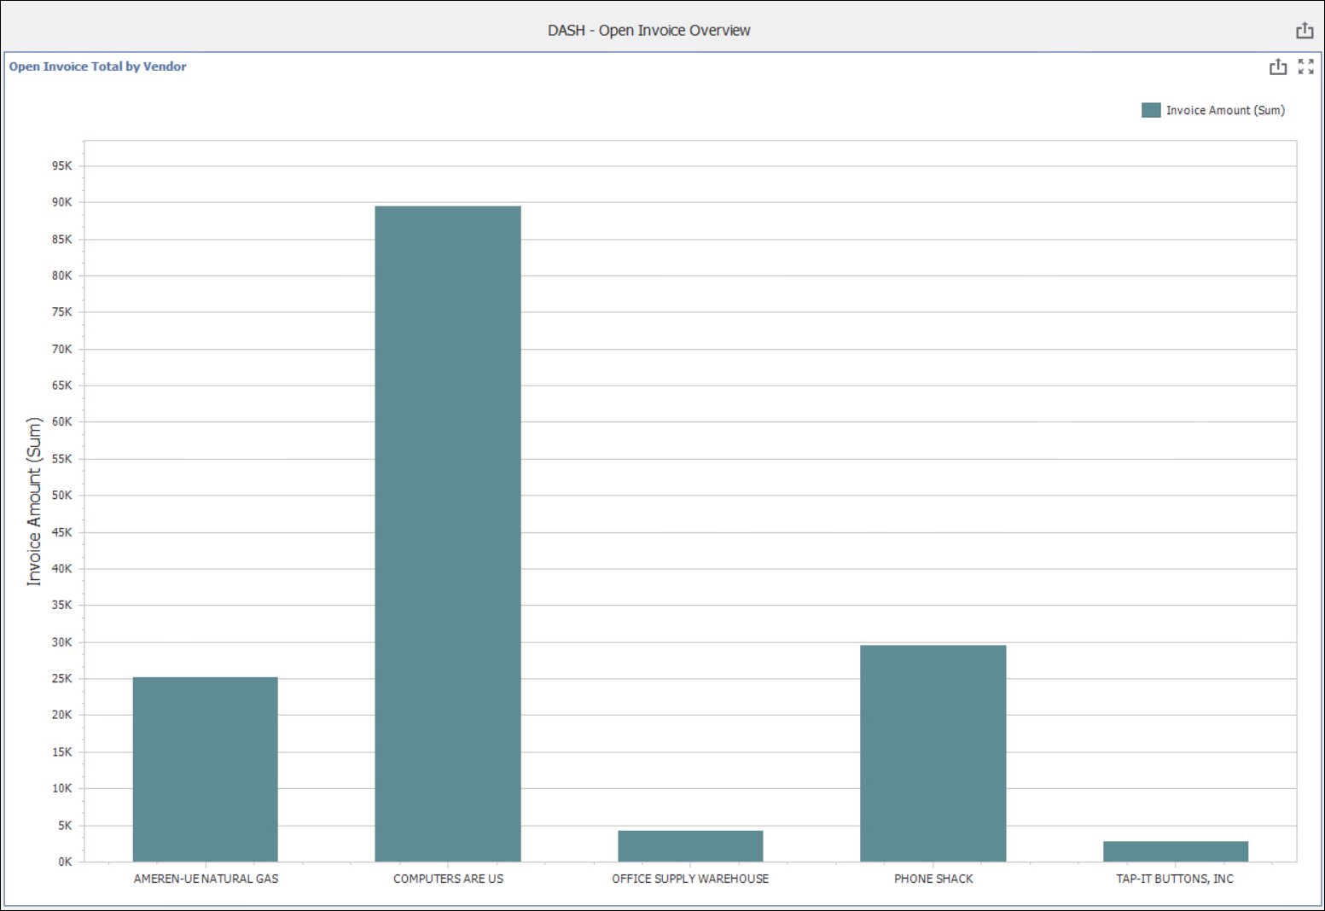
- Navigate back to the Dashboard Designer Home ribbon and click Save
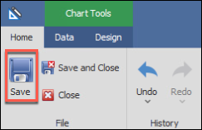

Choropleth Dashboard Item
A Choropleth Map inserts a visual diagram of where on a map the data is relevant.
- From the Dashboard Designer Home ribbon, click Choropleth Map
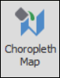
- From the Data Provider pane list, drag the following column names into the appropriate Data Item in the Data Items as illustrated below:
  - State to the Attribute Data Item blank.
  - Invoice Amount to the Maps Data Item blank.
  - Invoice # to the second Maps Data Item blank.
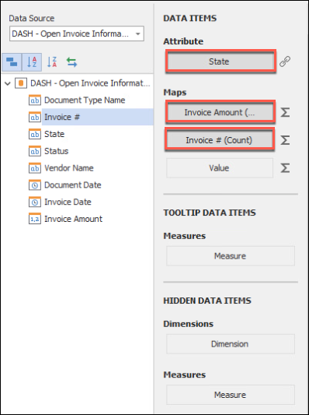
Attribute Data Item: The column used to group the total by (in this case we want the states we have invoices for).
Maps Data Item: The columns used for total counts (in this case we want invoice amount total per state and the invoice count).
- Navigate to the Dashboard Designer Design ribbon and click Default Map
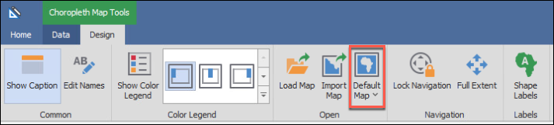
- Select USA from the resulting menu
A map of the United States is displayed in the Dashboard Item.
- Navigate back to the Data Items pane (second column left-side pane)
- Under Attribute, click the link symbol to the right of the State attribute
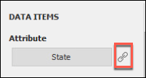
The Map Attribute Binding dialog is displayed.
- Click the Bind a data member to: drop-down. Scroll down to the bottom of the list and select POSTAL
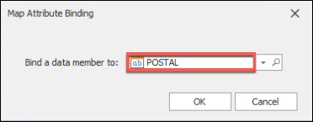
- Click OK
The Postal selection here ties to the data in the Data Provider.
In this example, we have a Keyword Type called State that is entered in OnBase as a two-letter abbreviation. We make that binding here!
Had we not asked you to select the POSTAL attribute from the drop-down, the Magnifying Glass button (pictured above to the right of the drop-down) would have allowed you to scroll through examples of attributes/data to help with finding the appropriate binding.
- From the Dashboard Designer Design ribbon, click Edit Names
The Edit Names dialog is displayed.
- Type Open Invoices by State in the Dashboard Item Name field
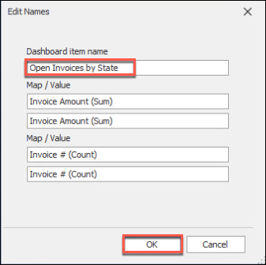
- Click OK
- From the Dashboard Designer Design ribbon, click Show Color Legend
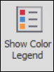
- From the Dashboard Designer Design ribbon, Click the lower button to the right of the Show Color Legend button (highlighted below in yellow)
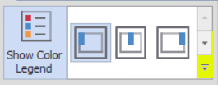
- From the resulting menu, select the Icon depicting the map legend being placed: Horizontal bottom-right
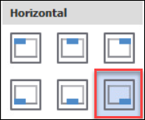
- Navigate to the Dashboard Designer Data ribbon and click Multiple Master Filter
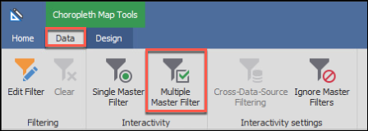
Enabling the Multiple Master Filter feature will allows users to click the states on the map to filter the results shown on the other Dashboard items.
The Map should look somewhat like the illustration below.
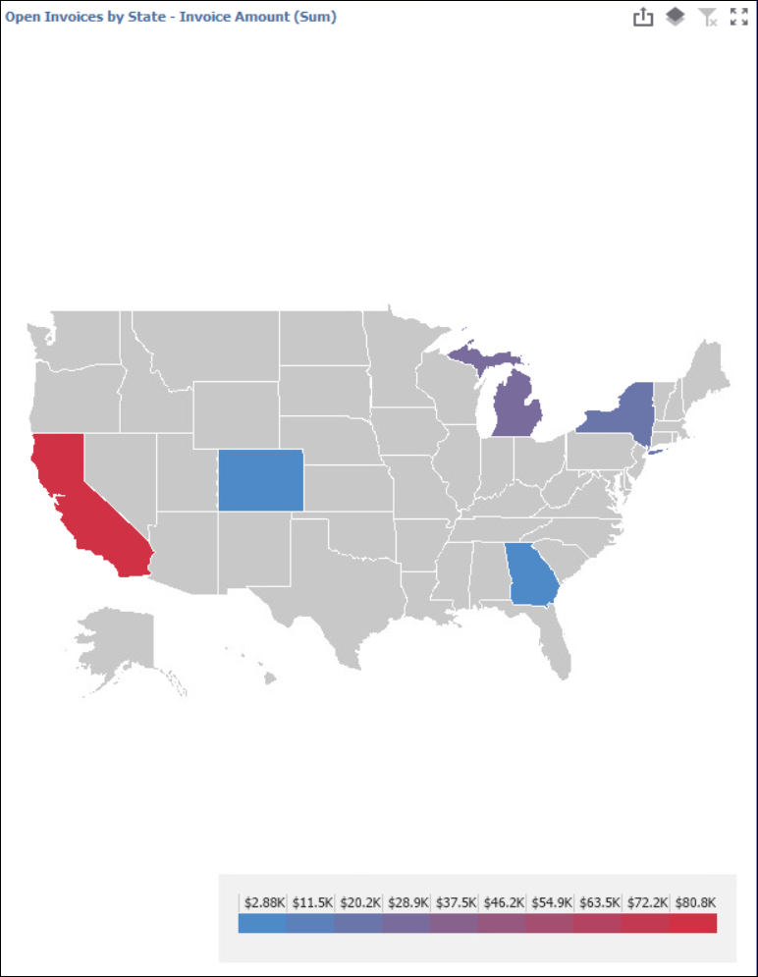
- Navigate to the Dashboard Designer Home ribbon and click Save

Range Filter Dashboard Item
A Range Filter allows the user viewing the dashboard to control (with a simple sliding scale) how much data is displayed for dashboard items that use the same data provider.
- From the Dashboard Designer Home ribbon, click Range Filter
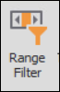
- From the Data Provider pane list, drag the following column names into the appropriate Data Item in the Data Items as illustrated below:
  - Drag Invoice Amount to the Values Data Item blank.
  - Invoice Date to the Argument Data Item blank.
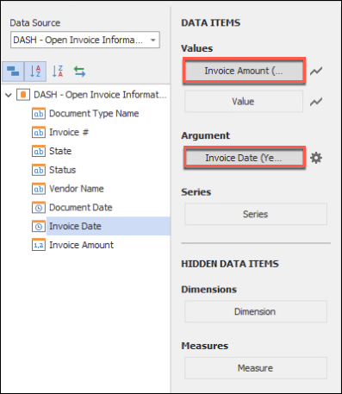
Value Data Item: This is the parameter for the Y (vertical) axis of the range filter.
Argument Data Item: This is the parameter for X (horizontal) axis of the range filter.
- Data will appear in the Range Filter. Test the functionality by dragging the handles at either end. Notice how the other dashboard items change based on the range you select in the Range Filter
Your Range Filter may look slightly different from the illustration below.
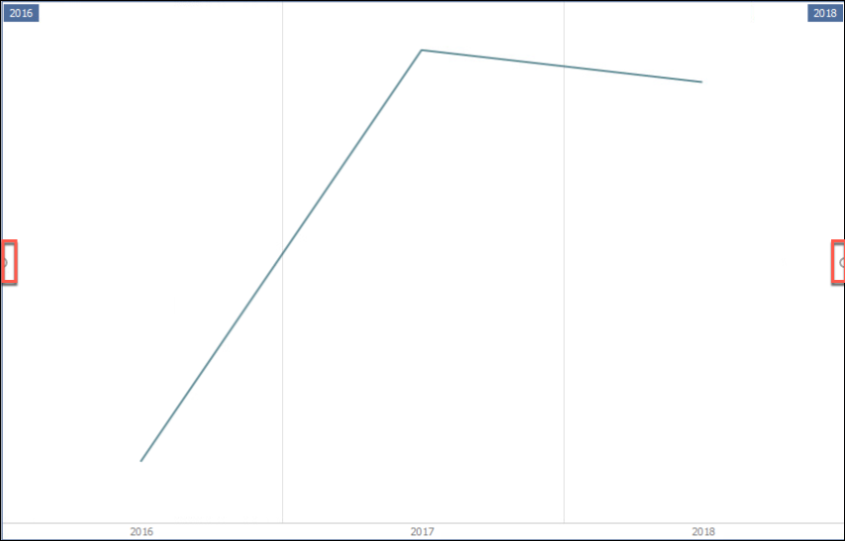
- From the Dashboard Designer Home ribbon, click Save and Close
The Dashboard is complete!
You are returned to the Dashboard Administration screen.
- Navigate back to the Gallery by clicking the Gallery button on the bottom-left of the screen
- Select the DASH Open Invoice Overview Dashboard you just created and explore
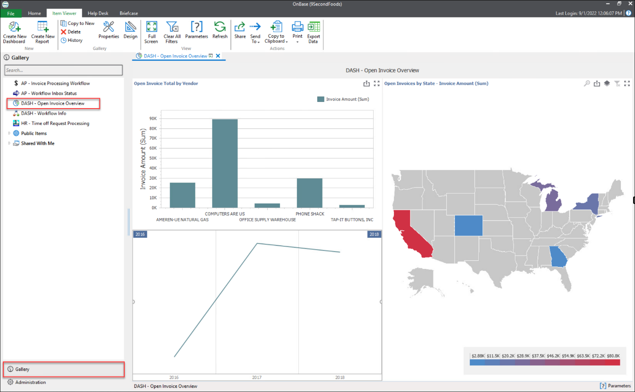

User Group Privileges
The following is for Reference Only.
Please do not perform the following steps.
In order to use Reporting Dashboards, a user must be a member of a User Group with appropriate privileges.
Privileges for Reporting Dashboards are set in OnBase Configuration.
To set privileges for Reporting Dashboards:
- In OnBase Configuration: From the Users menu, select User Groups / Rights
The User Groups & Rights dialog is displayed.
- Select the User Group to assign privileges to from the User Group Name list
- Click the Reporting Dashboards button
The Dashboard User Group Privileges dialog is displayed.
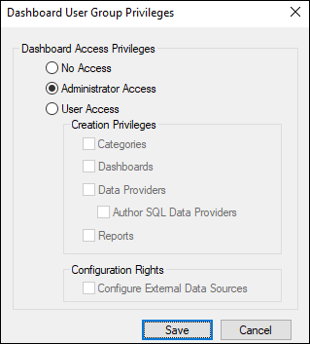
- Determine the level of access for the User Group by selecting the appropriate radio button:
- No Access: Members of the User Group cannot access any Reporting Dashboards functionality. This is the default setting for all User Groups.
- Administrator Access: Members of the User Group can view, create, and configure Dashboards, Data Providers, and Categories. They also have access to the Admin Tools under Administration, which include Purge functionality.
- User Access: Members of the User Group can view Dashboards they have been assigned to or that have been shared with them.
If User Access is selected, additional Creation Privileges check boxes are available, select any/all that apply. .
- Categories: Members of the User Group can create and configure custom Categories, which are used to organize Dashboards into groups of related Dashboards.
- Dashboards: Members of the User Group can create and configure custom Dashboards.
- Data Providers: Members of the User Group can create and configure Data Providers. Remember, Dashboards must be assigned to at least one Data Provider in order to function.
- Reports: Members of the User Group can create and configure custom reports.
If User Access is selected, additional Configuration Rights check boxes are available:
- Author SQL Data Providers: Members of the User Group can configure Data Providers that require custom SQL code.
- Configure External Data Sources: Members of the User Group can configure external databases for use with Reporting Dashboards.
External databases can only be used with the Custom SQL Query Data Provider.
SQL statements should only be edited or written by certified database administrators.

Sharing
The following is for Reference Only.
Please do not perform the following steps.
If you are the owner of a Dashboard or an administrator, you have the ability to share Dashboards and Categories with others.
Sharing a Dashboard
- From the Gallery, right-click the Dashboard that you own and wish to share
- Select Share from the resulting menu
The Choose people to share this dashboard with dialog is displayed.
- Click the Add button
The Select Users dialog is displayed.
- Select the people you would like to share the Dashboard with then click OK
You are returned to the Choose people to share this dashboard with screen.
- Click Share
Sharing a Category
Categories allow similar or related Dashboards to be grouped together in the Gallery view.
- From the Gallery, right-click the name of a Category that you own and wish to share
- Select Share
The Choose people to share this category with dialog is displayed.
- Click the Add button
The Select Users dialog is displayed.
- Select the people you would like to share the Category with then click OK
You are returned to the Choose people to share this category with screen.
- Click Share

Conclusion
- Thank you so much for taking the time to complete this course. Now that you have some experience with Reporting Dashboards, we hope you can envision many ways that interactive, real-time reporting (about the data in an OnBase system) can benefit your organization!

